Registry Tweak to Add “Copy as Path” Option in Files and Folders Context Menu in Windows

<http://www.askvg.com/registry-tweak-to-add-copy-as-path-option-in-files-and-folders-context-menu-in-windows/>

|  |
| --- |
| share this: [facebook](https://www.facebook.com/sharer.php?u=http://www.askvg.com/registry-tweak-to-add-copy-as-path-option-in-files-and-folders-context-menu-in-windows/" \o "Share on Facebook" \t "_blank) | [twitter](https://twitter.com/share?text=Registry%20Tweak%20to%20Add%20%E2%80%9CCopy%20as%20Path%E2%80%9D%20Option%20in%20Files%20and%20Folders%20Context%20Menu%20in%20Windows-&url=http://www.askvg.com/registry-tweak-to-add-copy-as-path-option-in-files-and-folders-context-menu-in-windows/) | [google+](https://plus.google.com/share?url=http://www.askvg.com/registry-tweak-to-add-copy-as-path-option-in-files-and-folders-context-menu-in-windows/) | [reddit](http://www.reddit.com/submit?url=http://www.askvg.com/registry-tweak-to-add-copy-as-path-option-in-files-and-folders-context-menu-in-windows/&title=Registry%20Tweak%20to%20Add%20%E2%80%9CCopy%20as%20Path%E2%80%9D%20Option%20in%20Files%20and%20Folders%20Context%20Menu%20in%20Windows" \o "Share on Reddit" \t "_blank) | [email](mailto:?subject=Registry%20Tweak%20to%20Add%20%E2%80%9CCopy%20as%20Path%E2%80%9D%20Option%20in%20Files%20and%20Folders%20Context%20Menu%20in%20Windows&body=http://www.askvg.com/registry-tweak-to-add-copy-as-path-option-in-files-and-folders-context-menu-in-windows/) | [leave a comment](http://www.askvg.com/registry-tweak-to-add-copy-as-path-option-in-files-and-folders-context-menu-in-windows/#respond) |
|  |

Windows Vista, Windows 7 and Windows 8 comes with many new and advanced context menu options which were not available in Windows XP, "Copy as Path" option is one of them.

"**Copy as Path**" option appears whenever you press "Shift" key and right-click on a file or folder. This option automatically copies the full path of the selected file or folder to clipboard. It might come very useful in many situations.

We have shared a few freeware to get this option in **Windows XP** which can be downloaded using following link:

[How to Get Windows Vista and 7's "Copy as Path" Option in Windows XP Context Menu?](http://www.askvg.com/how-to-get-windows-vista-and-7s-copy-as-path-option-in-windows-xp-context-menu/)

In the above mentioned topic, one AskVG reader "Stamimail" asked for a Registry tweak to add the same option without using any 3rd party software. I tried the code given by another reader "Allal" in the same topic but it didn't work. After a little tweaking, I got success in adding the "Copy as Path" option in files and folders context menu with the help of Registry Editor.

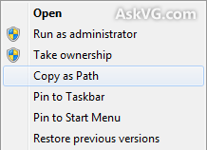

So if you also want to enjoy "Copy as Path" option, check out following simple steps:

**1.** Type **regedit** in RUN dialog box and press Enter. It'll open Registry Editor.

**2.** Now go to following key:

HKEY\_CLASSES\_ROOT\\*\shell

**3.** Under **shell** key, create a new key and set its name to **Copy as Path**.

**4.** Now create another new key under the new **Copy as Path** key and set its name to **command**.

So the final path would be:

HKEY\_CLASSES\_ROOT\\*\shell\Copy as Path\command

**5.** Now click on **command** key and in right-side pane, set the value of **(Default)** to:

cmd.exe /c echo "%1"|clip

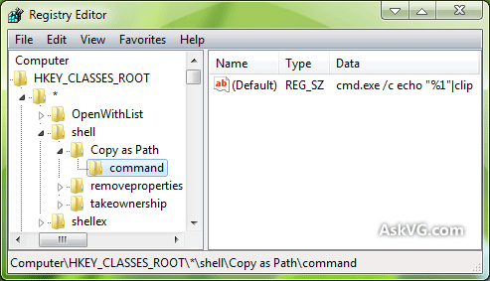

That's it. It'll immediately add the "Copy as Path" option in files context menu. Just right-click on a file and select "Copy as Path" option and it'll copy the full path to clipboard. You can paste it in a text editor, browser or anywhere else.

**NOTE:** The above mentioned code copies the path within double-quotes (""). If you don't want the double-quotes, use following code instead:

cmd.exe /c echo %1|clip

**6.** If you also want to add "Copy as Path" option in folders context menu, follow the same steps 3-5 for following key as well:

HKEY\_CLASSES\_ROOT\Directory\shell

**PS:** If you don't want to modify Registry yourself and want a ready-made Registry script to do the task automatically, download following ZIP file, extract it and run the extracted REG file. It'll ask for confirmation, accept it:

[**Download Registry Script to Add "Copy as Path" Option in Windows**](http://media.askvg.com/downloads/2012/09/Add-Copy-as-Path-Option-in-Windows.zip)